**Kedir Nasir Omer Date: Nov. 28/2022**

**UC SanDiego- Big Data Specialization**

**2.3. Evaluation**

* **Classifying in KNIME to identify big spenders in Catch the Pink Flamingo**

Below is a screenshot of the confusion matrix

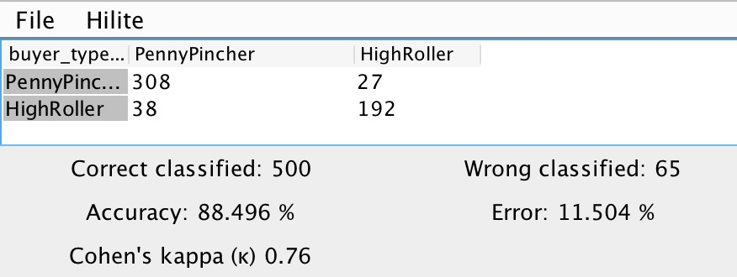

* The above screenshot demonstrates that the model's **overall accuracy** is **88.496%.**
* **PennyPincher** buyers were classified correctly **308 times** and incorrectly 27 times by the model. When the byer type is a **HighRoller**, the model correctly identified the byer type **192 times** while misclassifying it 38 times.